**Programming Assignment 5 – Chapter 10**

**Instructions**

**a.**

Make a class Employee with a name and salary. Make a class Manager inherit from Employee. Add an instance variable, named _department, that stores a string. Supply a method __repr__ that prints the manager’s name, department, and salary. Make a class Executive inherit from Manager. Supply appropriate __repr__ methods for all classes. Supply a test program that tests these classes and methods.

Sample output:

John Smith has a salary of 45000.00

Jane Doe has a salary of 60000.00 and manages the Widgets department

Weird Guy has a salary of 90000.00 and is the executive for the Thingies Department

**Code**

**employees.py**

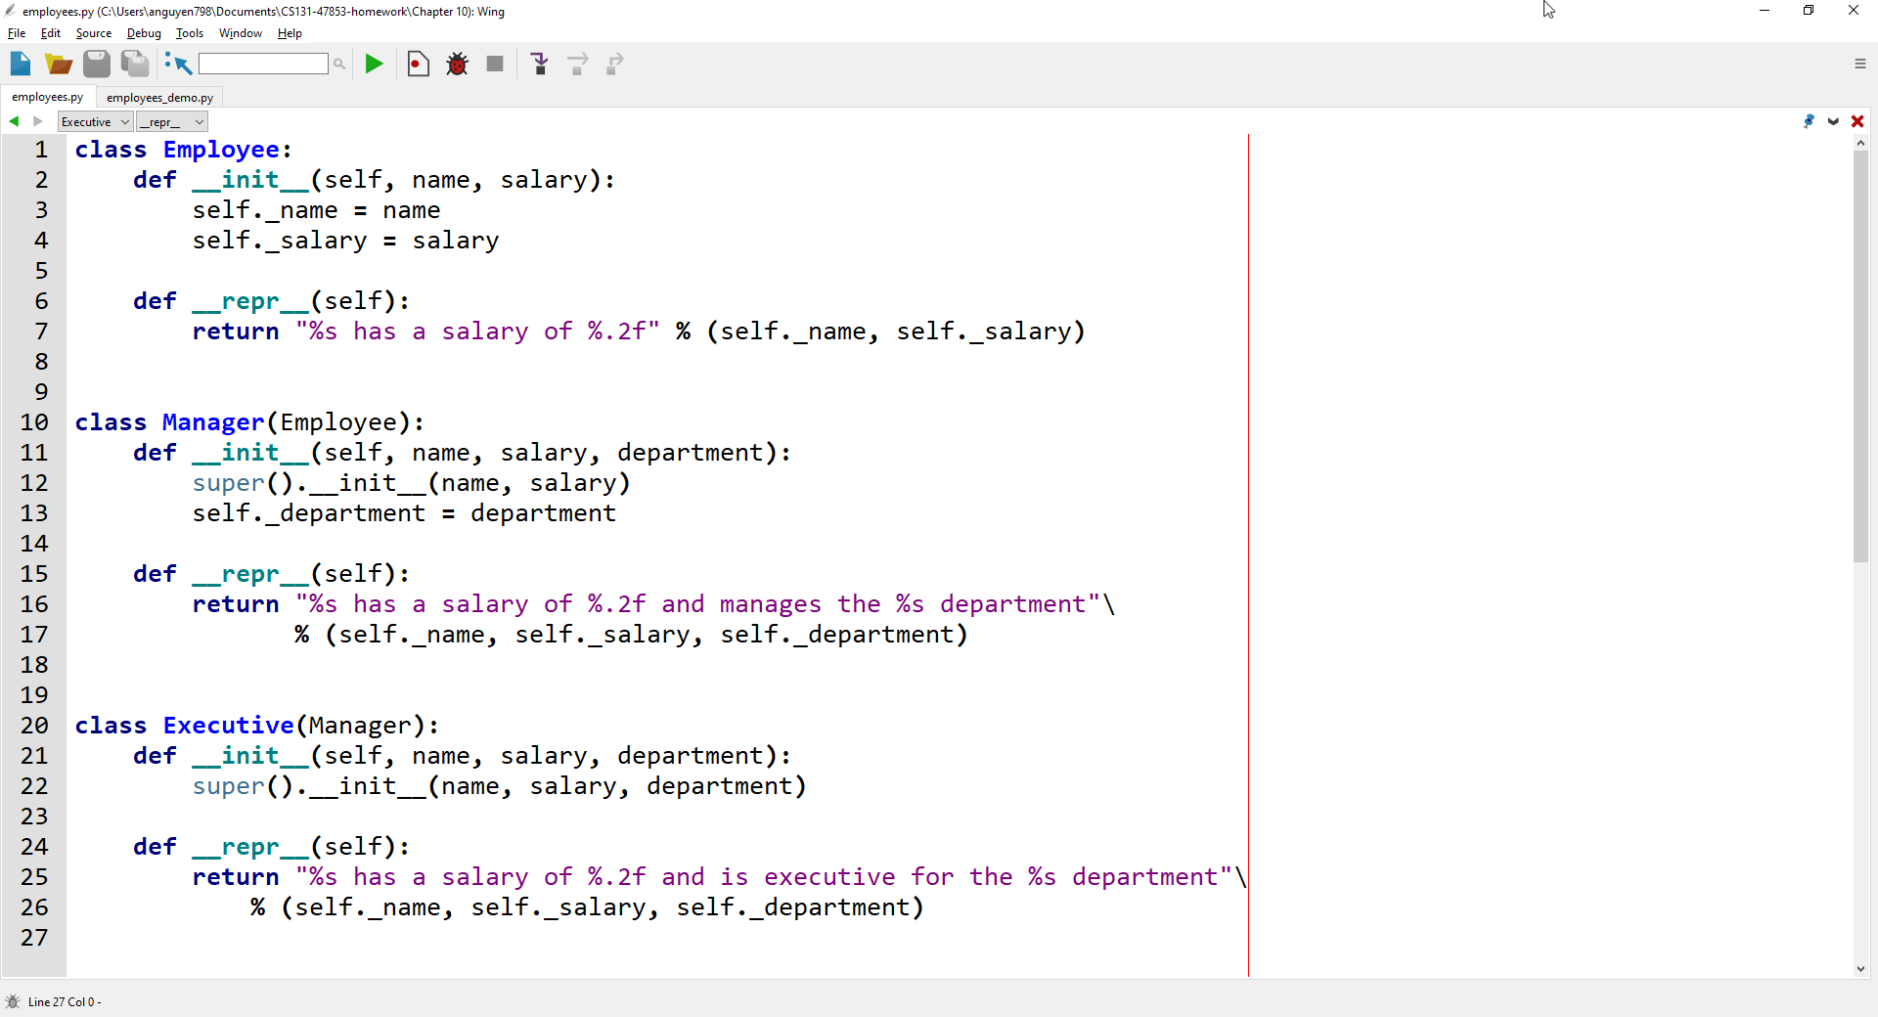

**employeesDemo.py (import PA_Car.py Car class)** 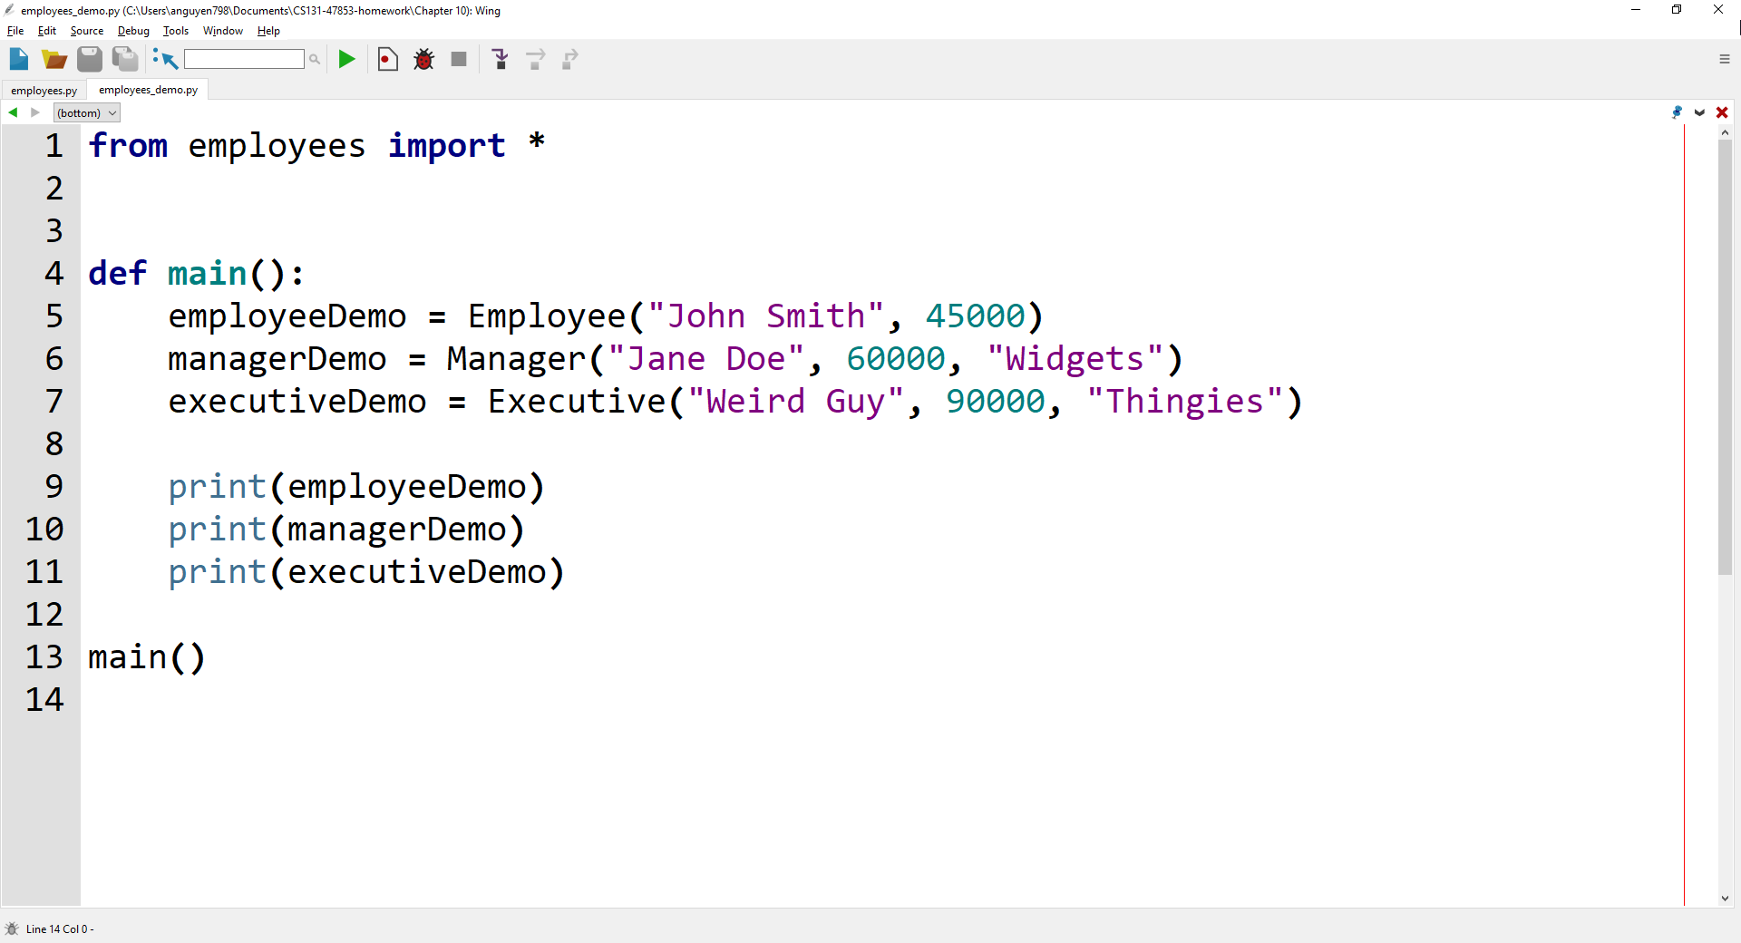

**Output**

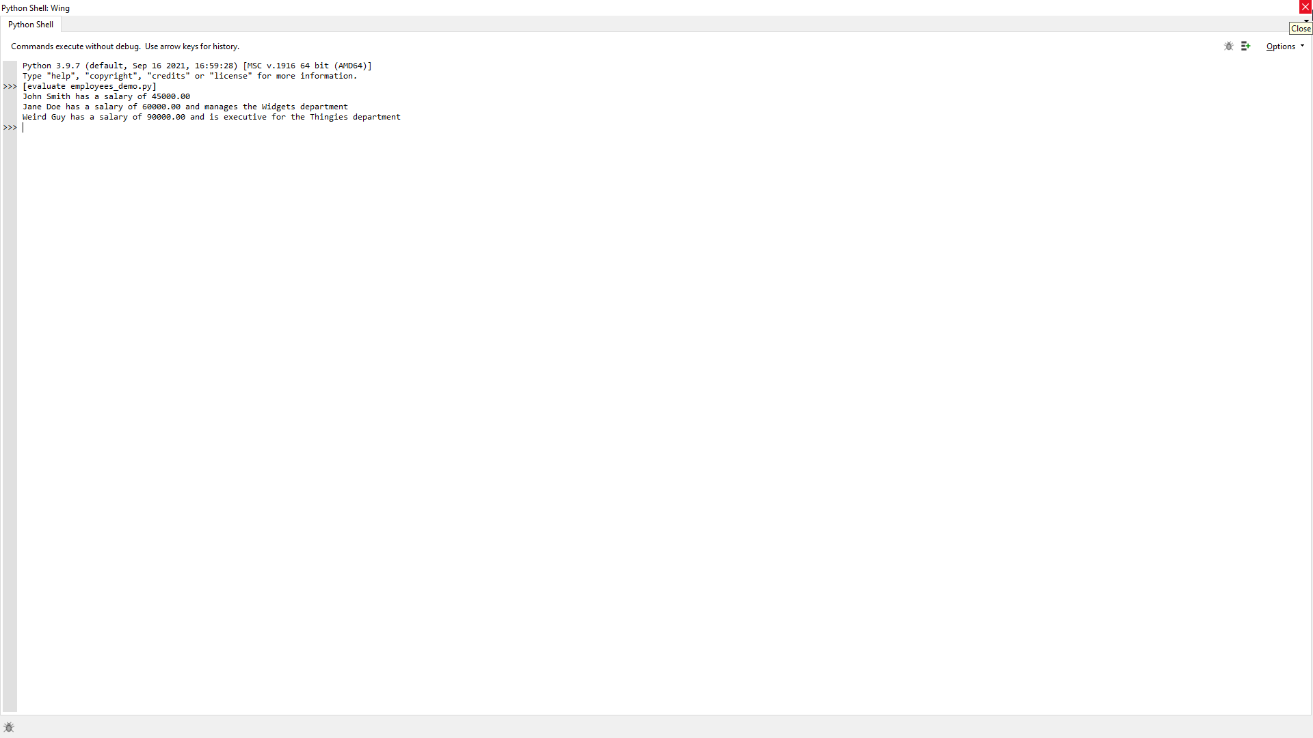

**Lab 9 – Written Code**

**employees.py**

class Employee:

    def __init__(self, name, salary):

        self._name = name

        self._salary = salary

    def __repr__(self):

        return "%s has a salary of %.2f" % (self._name, self._salary)

class Manager(Employee):

    def __init__(self, name, salary, department):

        super().__init__(name, salary)

        self._department = department

    def __repr__(self):

        return "%s has a salary of %.2f and manages the %s department"\

               % (self._name, self._salary, self._department)

class Executive(Manager):

    def __init__(self, name, salary, department):

        super().__init__(name, salary, department)

    def __repr__(self):

        return "%s has a salary of %.2f and is executive for the %s department"\

            % (self._name, self._salary, self._department)

**employees_demo.py**

from employees import *

def main():

    employeeDemo = Employee("John Smith", 45000)

    managerDemo = Manager("Jane Doe", 60000, "Widgets")

    executiveDemo = Executive("Weird Guy", 90000, "Thingies")

    print(employeeDemo)

    print(managerDemo)

    print(executiveDemo)

main()